
Vertex® Tax Links for Salesforce Commerce Cloud Configuration guide SFRA version
Setup guide
Table of Contents
Summary 3
Chapter 1. Custom Code Changes 3
Form definitions 3
address.xml 3
Scripts 4
shipping.js 4
Templates 7
Resources 10

Summary
This document refers to Vertex® Tax Links for Salesforce Commerce Cloud Configuration guide. The cartridge is designed for Salesforce Commerce Cloud API version 19.10 (Compatibility Mode: 19.10) with SFRA version 4.4.1. In case the service is down, the storefront continues to work without the service. All errors work of the service are saved in the log file
All configuration parameters and steps can be found there. The only difference is the Custom Code section and Enable SFRA toggle in Custom Preferences section in BM.

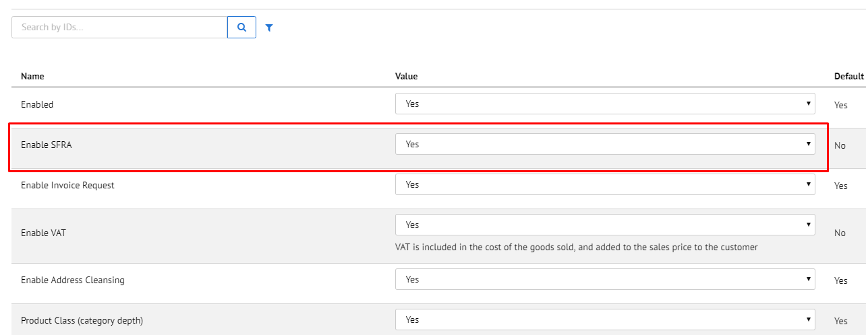

Chapter 1. Custom Code Changes
All changes should be be made to a merchant’s custom cartridge. This functionality is implemented in int_vertex_sfra cartridge for default Storefront Reference Architecture where you can find the code.

Form definitions

address.xml

Open app_storefront_base/cartridge/forms/default/address.xml
add code after line 32 as follows:
<!-- Customer Tax Registration Number -->
<field formid="taxnumber" label="label.input.taxnumber" type="string" mandatory="false" min-length="2" max-length="10" binding="taxnumber"
missing-error="resource.errortaxnumber"/>

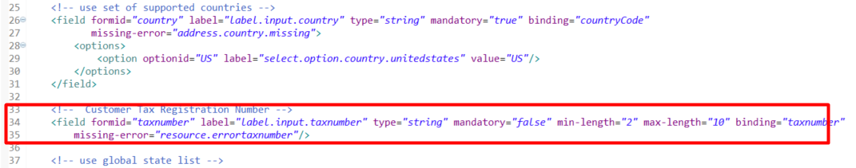

Scripts
Note: Don't forget to build your js code after these changes.

shipping.js

  - Open <YOUR_STOREFRONT_CARTRIDGE>/cartridge/client/default/js/checkout/shipping.js
modify code near line 501 in the shippingFormResponse function so that the code looks similar to the below:
else if (data.vertexError){
showVertexErrors(data, $('.vertexError'), $('.vertexSuggestions'), $('#vertex-suggestion'));
}

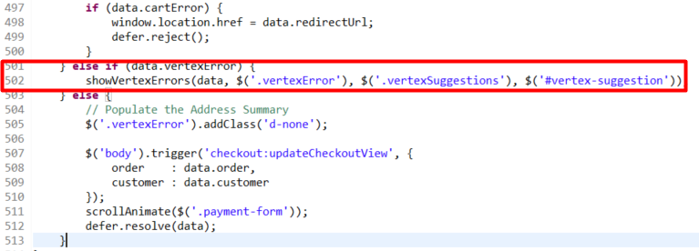

  - Add code after line 1009:
var vertexErrorBlock = $($rootEl).parent().find('.vertexError');
var vertexSuggestionBlock = $($rootEl).parent().find('.vertexSuggestions');
var vertexAddresses = $($rootEl).parent().find('#vertex-suggestion');

  - Modify code near line 1026 in the saveMultiShipInfo function so that the code looks similar to the below:
if (response.vertexError) {
showVertexErrors(response, vertexErrorBlock, vertexSuggestionBlock, vertexAddresses);
} else {

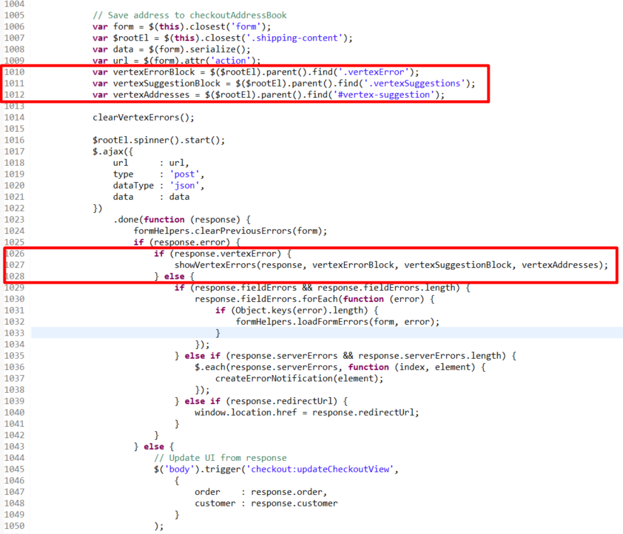
  - Add code at the end of the module.exports section:

vertexSuggestions: function () {
$('select[name="vertex-suggestion"]').change(function (item) {
var form = $(this).closest('.card').find('.shipping-form');
fillAddressSuggestion($(this).find('option:selected').data('address'), form);
});
}

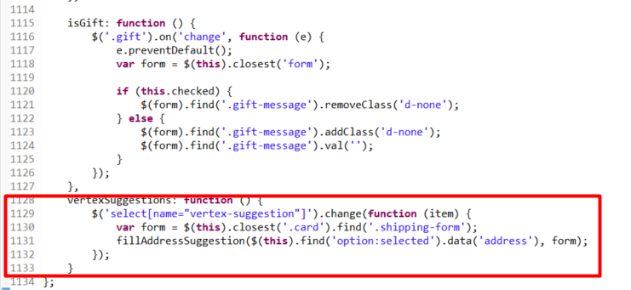
  - Add code at the end of the file:

/**
*
* @param {Object} address - Suggested address
* @param {Object} form - current form
*/
function fillAddressSuggestion(address, form) {
$('.btn-show-details').trigger('click');
var url = $('#vertex-suggestions').data('suggest');
$.ajax({
url : url,
type : 'post',
dataType : 'json'
})
$(form).find('input[name$=_address1]').val(address.address1);
if (address.address2) {
$(form).find('input[name$=_address2]').val(address.address2);
}
$(form).find('input[name$=_city]').val(address.city);
$(form).find('input[name$=_postalCode]').val(address.postalCode);
$(form).find('select[name$=_stateCode],input[name$=_stateCode]').val(address.stateCode);
$(form).find('select[name$=_country]').val(address.countryCode.toUpperCase());
}
/**
* @description clears error container
*/
function clearVertexErrors() {
$('.vertexError').addClass('d-none');
$('.vertexSuggestions').addClass('d-none');
}

/**
* @description view Vertex error container
*
* @param {Object} data - response data
* @param {string} vertexErrorBlock - vertexErrorBlock
* @param {string} vertexSuggestionBlock - vertexSuggestionBlock
* @param {Object} vertexAddresses - vertexAddresses container
*/
function showVertexErrors(data, vertexErrorBlock, vertexSuggestionBlock, vertexAddresses) {
if (!data.vertexAddressSuggestions) {
vertexErrorBlock.removeClass('d-none');
} else {
vertexSuggestionBlock.removeClass('d-none');
$(vertexAddresses).html('');
data.vertexAddressSuggestions.forEach(function (item, i, vertexAddressSuggestions) {
var aid = item.UUID ? item.ID : item.key;
if (i < 2) {
$(vertexAddresses).append(
$('<option></option>')
.attr('value', aid)
.text("(" + (aid) + ")" + " " + item.address1 + " " + item.city + " " + item.stateCode + " " + item.postalCode)
.attr('data-address', JSON.stringify(item)));
}
});
}
}

Templates

  - Open <YOUR_STOREFRONT_CARTRIDGE>/cartridge/templates/default/account/addressForm.isml
add code near line 155 as follows:

<!-- Tax registration Number -->
<div class="form-group
${pdict.addressForm.taxnumber.mandatory === true ? 'required' : ''}">
<label class="form-control-label" for="taxnumber">
<isprint value="${pdict.addressForm.taxnumber.label}" encoding="htmlcontent" />
</label>
<input type="text" class="form-control" id="taxnumber"
<isprint value="${pdict.addressForm.taxnumber.attributes}" encoding="off" />>
<div class="invalid-feedback"></div>
</div>

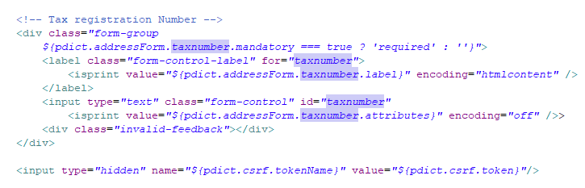

  - Open <YOUR_STOREFRONT_CARTRIDGE>/cartridge/templates/default/checkout/billing/billingAddress.isml
add code near line 155 as follows:

<div class="row">
<div class="col-sm-12">
<div class="form-group
${billingFields.taxnumber.mandatory === true ? 'required' : ''}
${billingFields.taxnumber.htmlName}">
<label class="form-control-label" for="billingCustomerTax">
${Resource.msg('field.shipping.address.customertax','address',null)}
</label>
<input type="text" class="form-control billingCustomerTax" id="billingCustomerTax"
value="${pdict.order.billing.billingAddress.address
&& pdict.order.billing.billingAddress.address.taxnumber
? pdict.order.billing.billingAddress.address.taxnumber
: ''}"<isprint value=${billingFields.taxnumber.attributes} encoding="off"/>>
<div class="invalid-feedback"><isprint value="${billingFields.taxnumber.error}" ></div>
<span>${Resource.msg('example.customertax','forms',null)}</span>
</div>
</div>
</div>

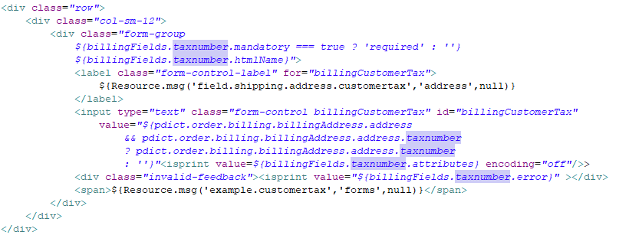

  - Open <YOUR_STOREFRONT_CARTRIDGE>/cartridge/templates/default/checkout/shipping/
shipping.isml
add code near line 12 as follows:

<div class="vertex-error">
<isinclude template="vertex/suggestions" />
</div>

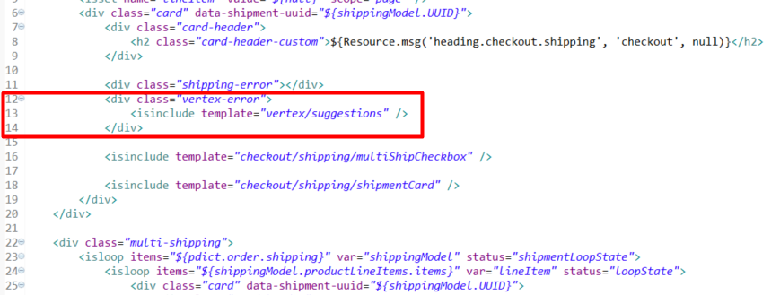
  - Open <YOUR_STOREFRONT_CARTRIDGE>/cartridge/templates/default/checkout/shipping/
shippingAddress.isml
add code near line 141 as follows:

<isif condition="${dw.system.Site.current.getCustomPreferenceValue('Vertex_isVATEnabled')}">
<div class="row">
<div class="col-sm-12">
<div class="form-group
${addressFields.taxnumber.mandatory === true ? 'required' : ''}
${addressFields.taxnumber.htmlName}">
<label class="form-control-label" for="shippingCustomerTax">
${Resource.msg('field.shipping.address.customertax','address',null)}
</label>
<input type="text" class="form-control shippingCustomerTax" id="shippingCustomerTax"
value="${shippingAddress.taxnumber||''}" <isprint value=${addressFields.taxnumber.attributes} encoding="htmlsinglequote"/>>
<div class="invalid-feedback"><isprint value="${addressFields.taxnumber.error}" encoding="htmlcontent"/></div>
<span>${Resource.msg('example.customertax','forms',null)}</span>
</div>
</div>
</div>
</isif>

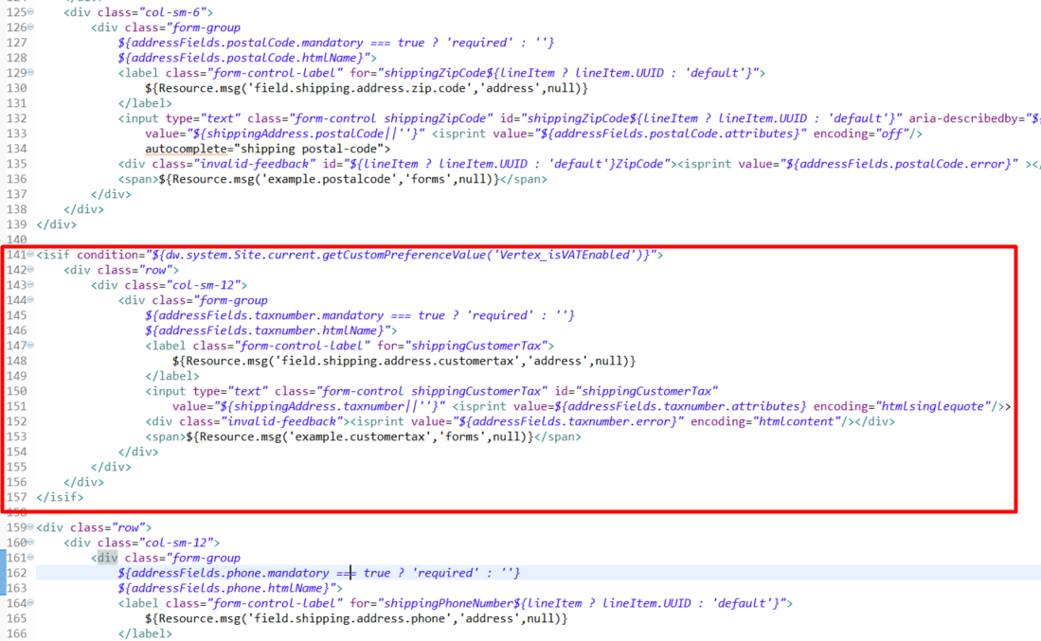

Resources

  - Open <YOUR_STOREFRONT_CARTRIDGE>/cartridge/templates/resources/forms.properties
add code near line 119 as follows:

field.shipping.address.customertax=VAT number
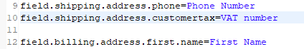
  - Open <YOUR_STOREFRONT_CARTRIDGE>/cartridge/templates/resources/address.properties
and add the following lines:

label.input.taxnumber=Tax Registration Number
error.message.taxnumber=Sorry, the tax number is missing.
example.customertax=Example: 4153334199

